Context level Diagram:

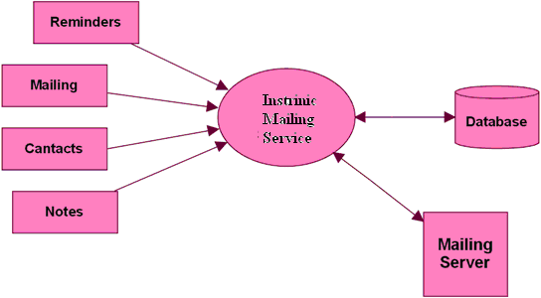

Level1 DFD for Mailing:

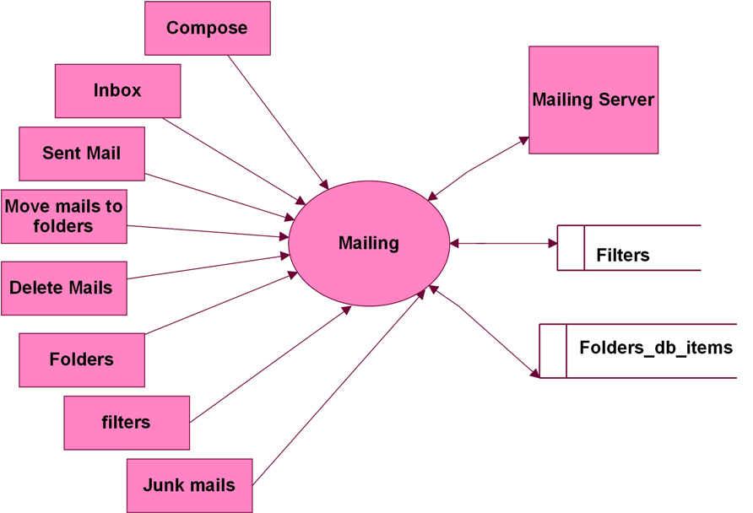

Level 1 DFD for Compose:

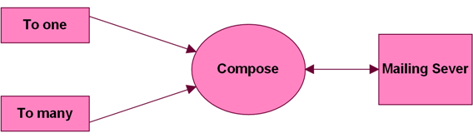

Level 1 DFD for inbox:

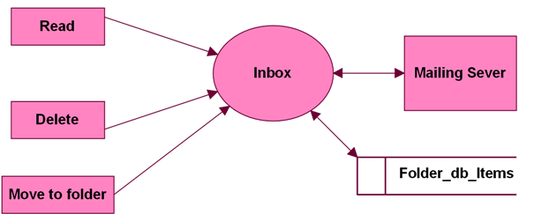

Level 2 DFD for Read:

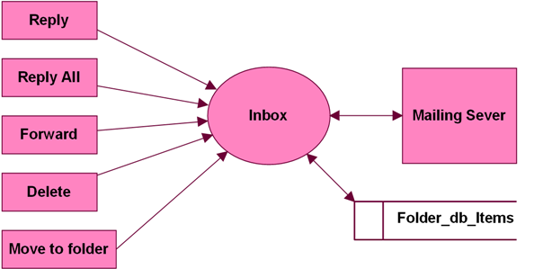

Level 1 DFD for Folders:

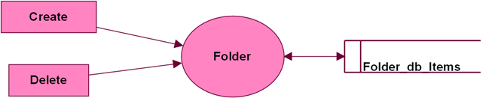

Level 1 DFD for Filter:

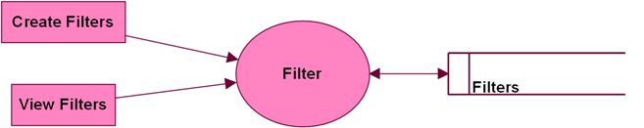

Level 2 for Create Filter:

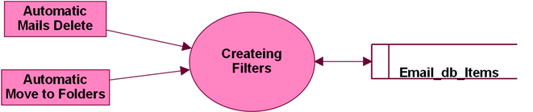

Level 3 DFD for Mailing (Automatic Mails Delete)

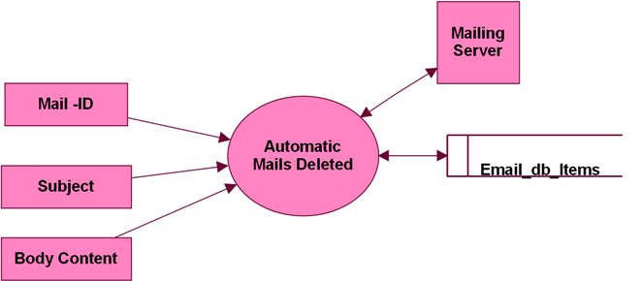

Level 1 DFD for

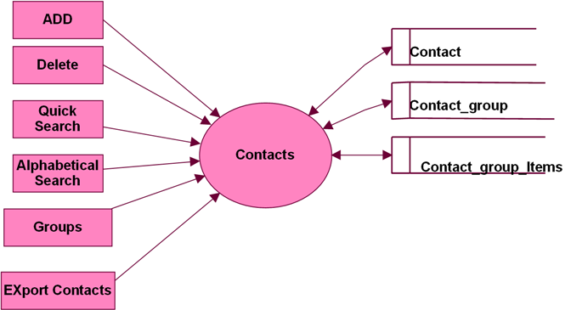

Level 1 DFD for Reminder:

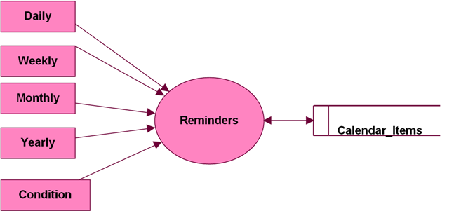

Level 2 DFD for Reminder Condition:

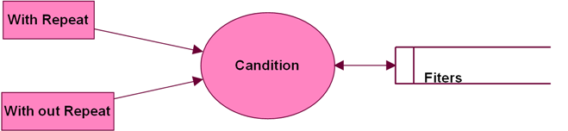

Level 1 DFD for Notes Module:

